**Step 1:**

Call the below API to find Drug name as input.

[https://api.fda.gov/drug/event.json?search=patient.drug.medicinalproduct:<Drug](https://api.fda.gov/drug/event.json?search=patient.drug.medicinalproduct:%3cDrug) Name>

Example.

<https://api.fda.gov/drug/event.json?search=patient.drug.medicinalproduct:HYDROXYZINE>

search medical product in the output JSON

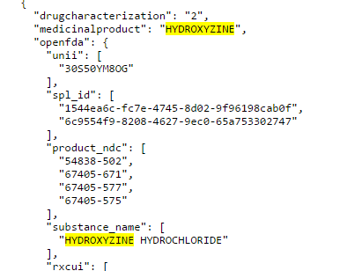

**Step 2:**

Use the substance Name in Second query

<https://api.fda.gov/drug/enforcement.json?search=openfda.substance_name:%22HYDROXYZINE%20HYDROCHLORIDE%22>

partial output snapshot below.

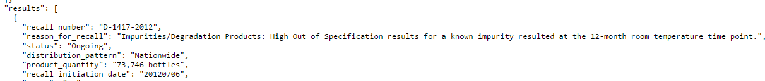

From the output Jason you have to display recall number, reason for recall and status in the recall message between chart and information table.

If there is no Recall for the substance you get below result.

{

  "error": {

    "code": "NOT_FOUND",

    "message": "No matches found!"

  }

}